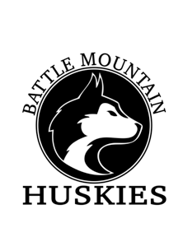
Husky Cross Country Invitational
Hosted by Battle Mountain High School
Date: Saturday, August 31, 2019
Location: Maloit Park, Minturn Nordic Center, 1 Academy Loop, Minturn, CO 81645

Race Schedule:
Open Race 9:15 am
Boys Varsity 10:00 am
Girls Varsity 10:30 am
Boys JV 11:10 am
Girls JV 11:50 am
Awards 12:30 pm
Middle School 1:00 pm

Race times will be subject to change pending the completion of the preceding race., This may require a race to start late, but no race will start early.

Entries: Registration is available on MileSplit – registration closes on 8/28 at 9:00pm.

Entry Fees: $150 for one High School team (boys or girls only), or $200 for both boys and girls teams. $150 per Middle School team. Check payable to: Battle Mountain HS Cross Country. If you haven’t already paid, please bring a check to the meet.

Awards: Top 15 individuals in each race. Trophies to top two boys and girls varsity teams.

Scoring: Varsity – run 7, score 5
JV – Unlimited entries, score 5
Middle School – Unlimited entries, score 5

Course Description: This is a challenging, lung-burning, hilly course course at altitude with grass and dirt track. It may be the most beautiful course you run all season. **Remember that Colorado weather can change suddenly and drastically, especially at altitude in the mountain areas. Please ask your runners to come prepared for any type of weather. We plan to hold the race, rain or shine!!

Parking: We will have designated bus parking and attendants who will be directing buses and spectators.

Team Camps: Please put team camps in the Northeast corner of the main field.

Event T-Shirts: Available for $15 at starting area

Restroom: Port-a-Potties on site

Questions: Contact
Rob Parish – Cross Country Coach, robert.parish@eagleschools.net
Gentry Nixon – Athletic Director, michelle.nixon@eagleschools.net

