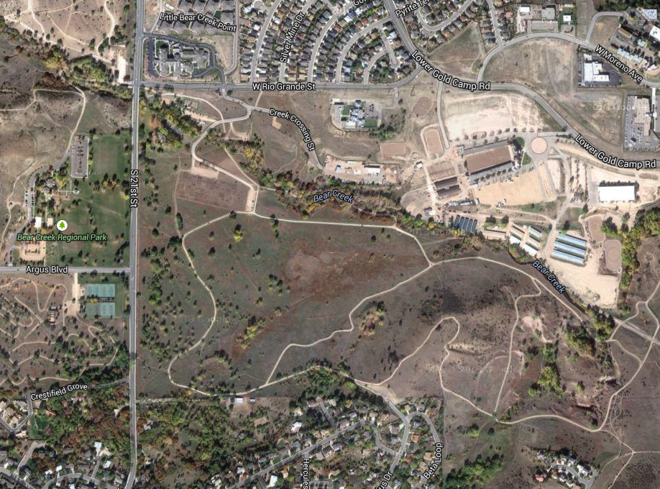

Bus Parking

**Activity Bus and Handicapped Parking Only** within park

**No Parking** at Dog Park

Parking in neighborhood

Parking

Parking