2019 5A Regions 1 and 2 CROSS COUNTRY COURSE
Aurora Sports Park - 19300 E Colfax Ave, Aurora, CO 80011
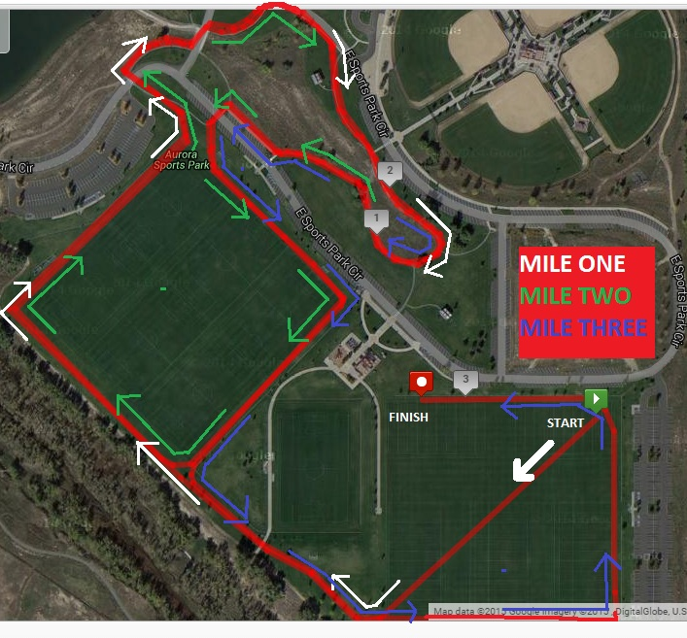
Coaches:
This course is a 2-loop format, so coaches and parents can see their runners multiple times during the race without much movement. Runners will find a well-marked course that is 95% grass or crushed fine dirt path.
There will be ample parking near the start/finish area, grass for your team camps, park restrooms + a few extra porta-potties near the finish line.

