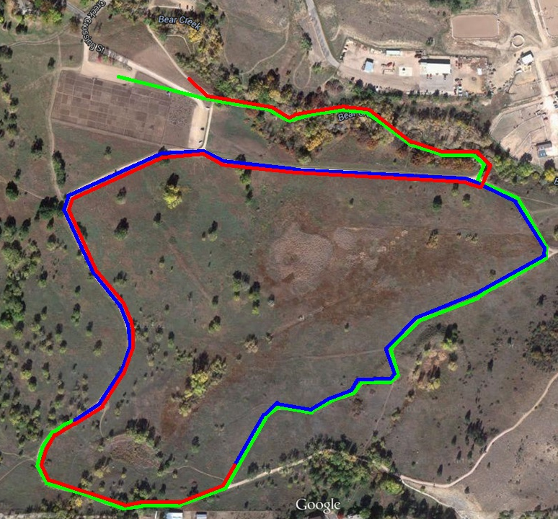

Team Camps

**Finish**

**Start**

Legend

Mile 1

Mile 2

Mile 3